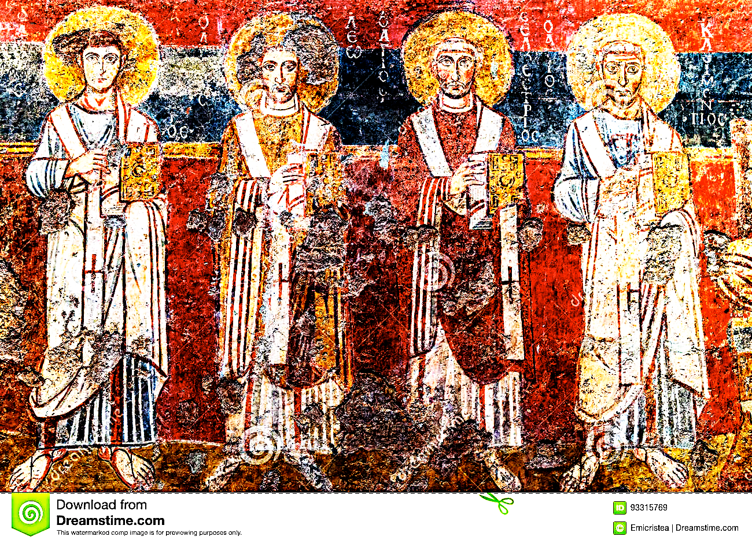

Fresco from Santa Maria Antiqua, Rome

**Introduction to Biblical Greek II**

**(THO 2194: Introduction to Biblical Greek – Part II)**

**Saint Paul University**

**[](https://ustpaul.ca/en/faculty-of-theology-home_47_42.htm)**

**Faculty of Theology**

**Winter Term, January 6 - April 4, 2020**

**Mondays & Wednesdays 5:30 – 7:00 pm**

**Prof. Michael Klaassen**

**The course is also available online, in real time and recorded**

**(Course code THO 2194W)**

|  |
| --- |
| **Registration is now open**  **SPU students register through their INTRANET account.**  **University of Ottawa students should register through their faculty.**  **All other students must register online** [**HERE**](https://ustpaul.ca/form-special-student.php)**.** |